Noah Smith

CIS 320

10/21/2019

Assignment 3

**Use Case Descriptions:**

1. View SRC Updates

Risk Level: Low

Primary Actor: Customer

Preconditions: Customer has an account

Postconditions: Customer views SRC updates

Main Flow:

1. Visitor goes to the SRC website
2. Visitor clicks on “Log Into Account”
3. Visitor is redirected to their profile
4. Visitor navigates to the about section
5. Visitor navigates to the updates section
6. Visitor reads the updates
7. Use case ends
8. View SRC Information

Risk Level: Low

Primary Actor: Customer

Preconditions: Customer has contact information

Postconditions: Customer viewed contact information

Main Flow:

1. Visitor goes to the SRC website
2. Visitor clicks on “Log Into Account”
3. Visitor is redirected to their profile
4. Visitor navigates to the about section
5. Visitor navigates to the information section
6. Visitor reads the information
7. Use case ends
8. View locker status

Risk Level: High

Primary Actor: Customer

Preconditions: Customer has a locker

Postconditions: Customer viewed locker status

Main Flow:

1. Visitor goes to the SRC website
2. Visitor clicks on “Log Into Account”
3. Visitor is redirected to their profile
4. Visitor clicks on “Locker Status”
5. Visitor reads their locker status
6. Use case ends
7. Register

Risk Level: High

Primary Actor: Customer

Preconditions: Customer account does not exist

Postconditions: Customer account is created

Main Flow:

1. Visitor goes to the SRC website
2. Visitor clicks on “Register”
3. Visitor is redirected to the create profile page
4. Visitor enters first name in the first name text box
5. Visitor enters last name in the last name text box
6. Visitor enters email in the email text box
7. Visitor enters student or faculty ID if applicable
8. Visitor enters address in the address text box
9. Visitor enters city in the city text box
10. Visitor selects state from the state combo box
11. Visitor enters zip in the zip code text box
12. Visitor enters password in the password text box
13. Visitor enters password in the re-enter password text box
14. Visitor clicks “Register” button at the bottom of the page
15. Visitor is directed to their account page
16. Visitor is added to the database
17. Visitor receives confirmation email
18. Use case ends
19. View membership options

Risk Level: High

Primary Actor: Customer

Preconditions: Customer account may or may not exist

Postconditions: Customer has viewed membership options

Main Flow:

1. Visitor goes to the SRC website
2. Visitor clicks on “Log Into Account”
3. Visitor is redirected to their profile
4. Visitor navigates to “Membership”
5. Visitor views the membership options
6. Use case ends
7. View room/space availability

Risk Level: Low

Primary Actor: Customer

Preconditions: Customer must have an account and a space must exist

Postconditions: Customer has viewed room/space availability

Main Flow:

1. Visitor goes to the SRC website
2. Visitor clicks on “Log Into Account”
3. Visitor is redirected to their profile
4. Visitor navigates to “Availability”
5. Visitor views the room/space availability
6. Use case ends

**Use Case Diagram:**

**Use Case Prototypes:**

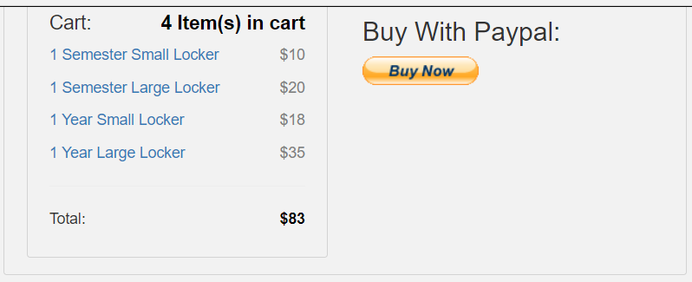 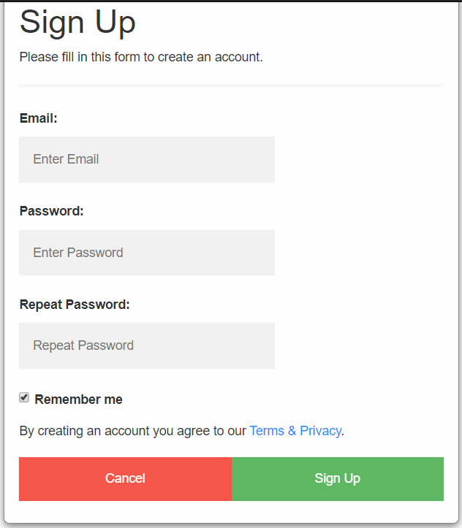 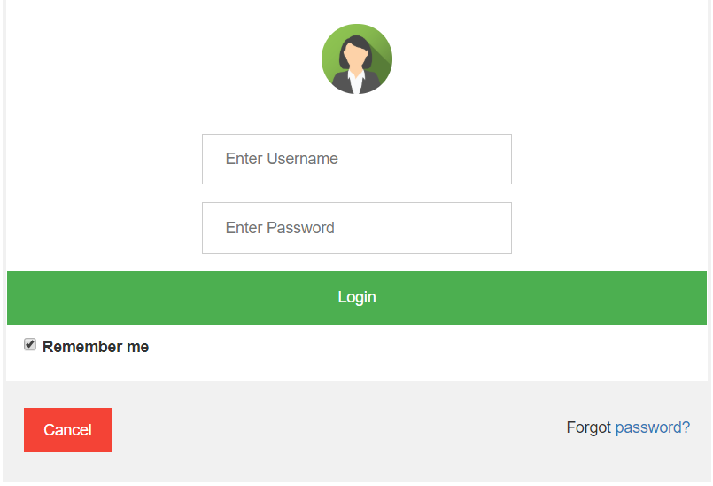

**Class Diagram:**

* 1. A screenshot of a cell phone

     Description automatically generated

* 1. A screenshot of a cell phone

     Description automatically generated
  2. A screenshot of a cell phone

     Description automatically generated
  3. A screenshot of a cell phone

     Description automatically generated

**Sequence Diagram:**

* 1. A screenshot of a social media post

     Description automatically generated

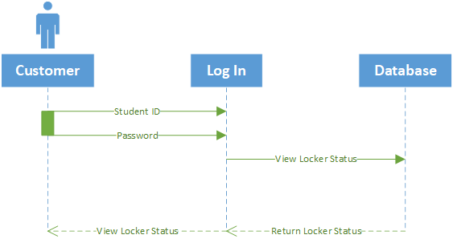

* 1. A screenshot of a social media post

     Description automatically generated

